**Indian Institute of Technology Kanpur**

**Thermodynamics (ESO201A)**

**Instructor: Jishnu Bhattacharya**

**Tutorial 10**





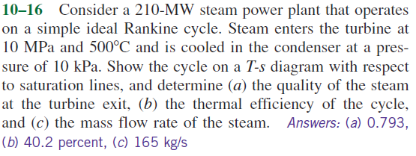

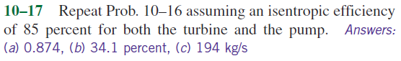

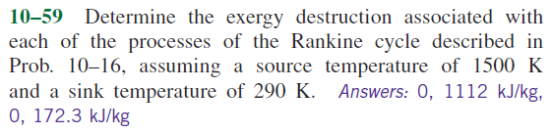

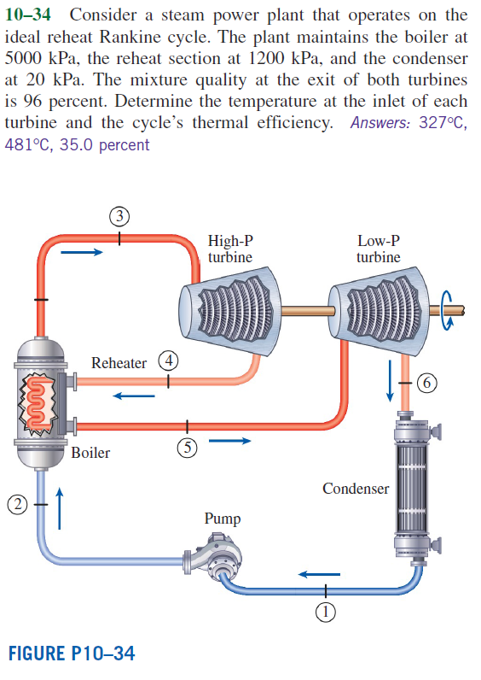

**Additional Homework Problems**

